**Monitoring Windows OS with Prometheus.**

Below, you can see a high-level architecture of Prometheus.

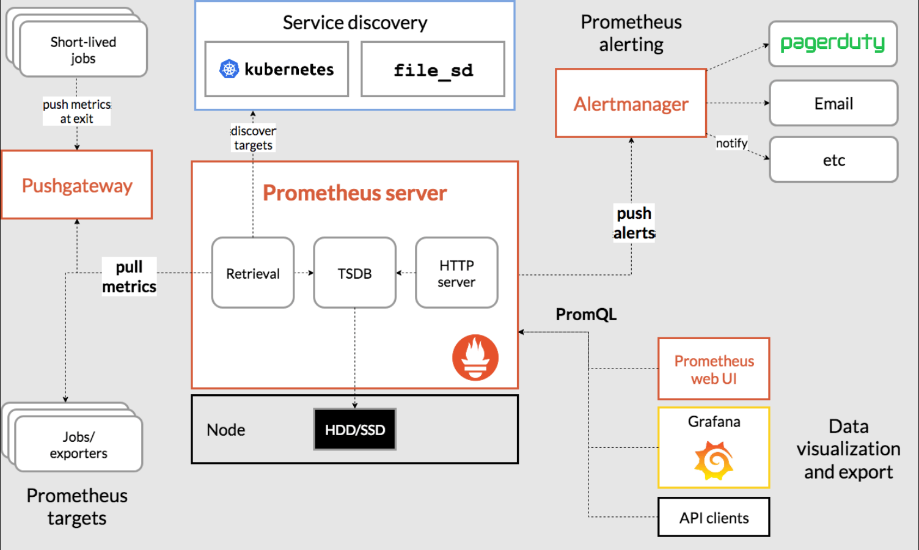

However, for now we are going to focus only on the Windows part:

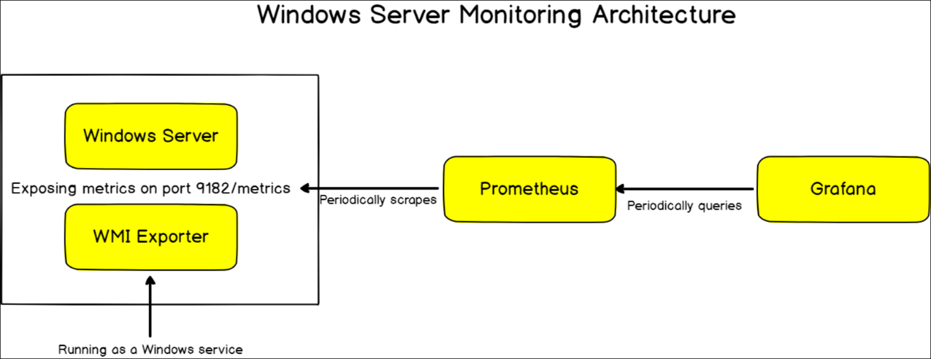

**1. Downloading and installing Windows Exporter and Prometheus.**

- The Windows Exporter is basically used for windows/windows servers to collect metrics such as CPU usage, memory and disk usage, and others. It is required in order for Prometheus to run properly.

- <https://github.com/prometheus-community/windows_exporter> - we can download and install the exporter through this link, navigating to the right side of the screen -> Releases 

Scrolling down, and selecting our desired version depending on our system:

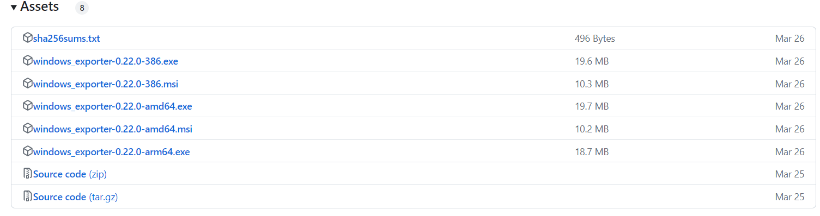

- <https://prometheus.io/download/> - then we download Prometheus from their official website, and select our version again:

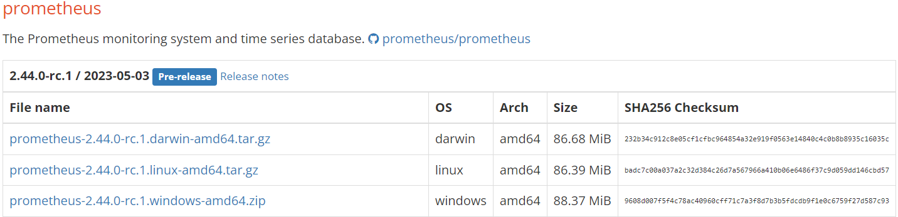

**2. Verifying the installation.**

- to check if we have installed Windows Exporter properly, we can open up a browser and navigate to http://localhost:9182/ as shown below:

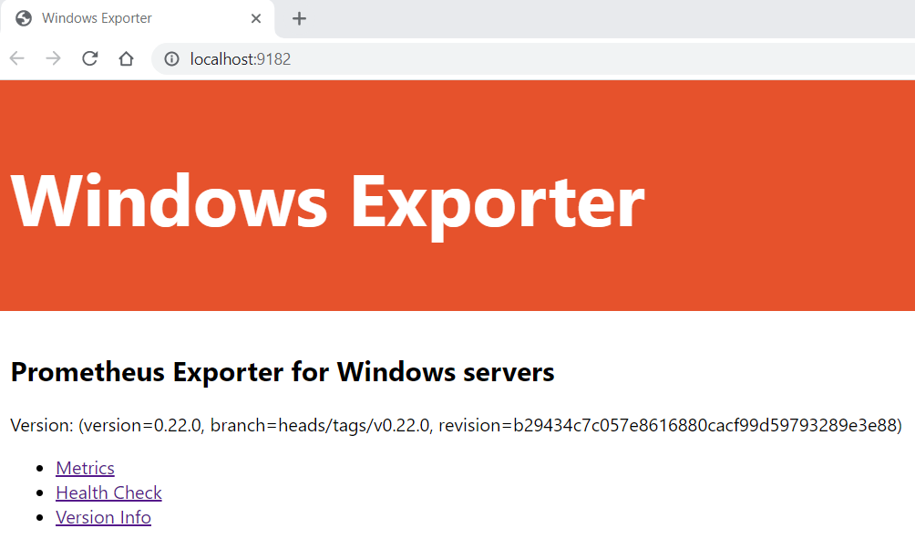

- we then have to add our Windows computer to Prometheus. For this, we need to know the IP address of it. To check the IP of our computer, we can just type the “ipconfig” command in our Command Prompt and look for the IPv4 address:

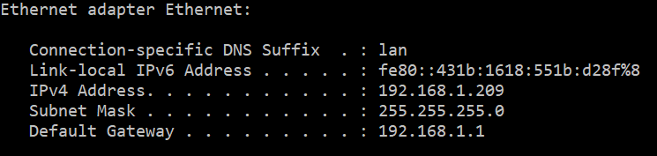

- the last step is to edit the prometheus.yaml file so we can add our computer as a “job”, using the IPv4 address with the Exporter port. I used notepad++ and added the following:

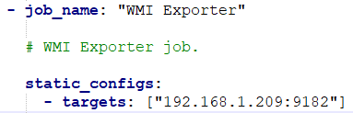

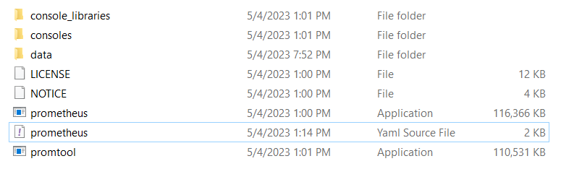

- we can now start Prometheus from the application file above.

- to check if we have installed Prometheus properly, we can open up a browser and navigate to http://localhost:9090/ as shown below:

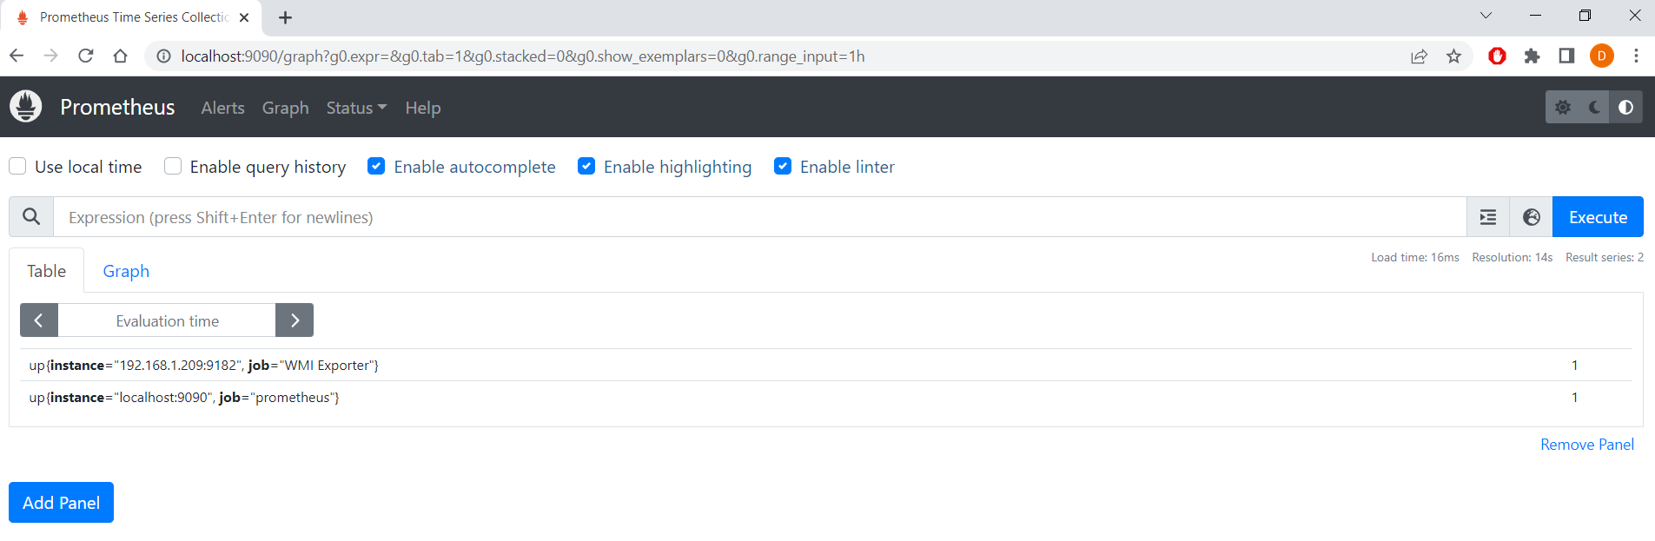

- if we press on Status -> Targets, we can see that our computer was properly added and is running, with the job name WMI Exporter (this name can be changed to your desire from the yaml file – for example, Windows 10/Win10 for your local machine).

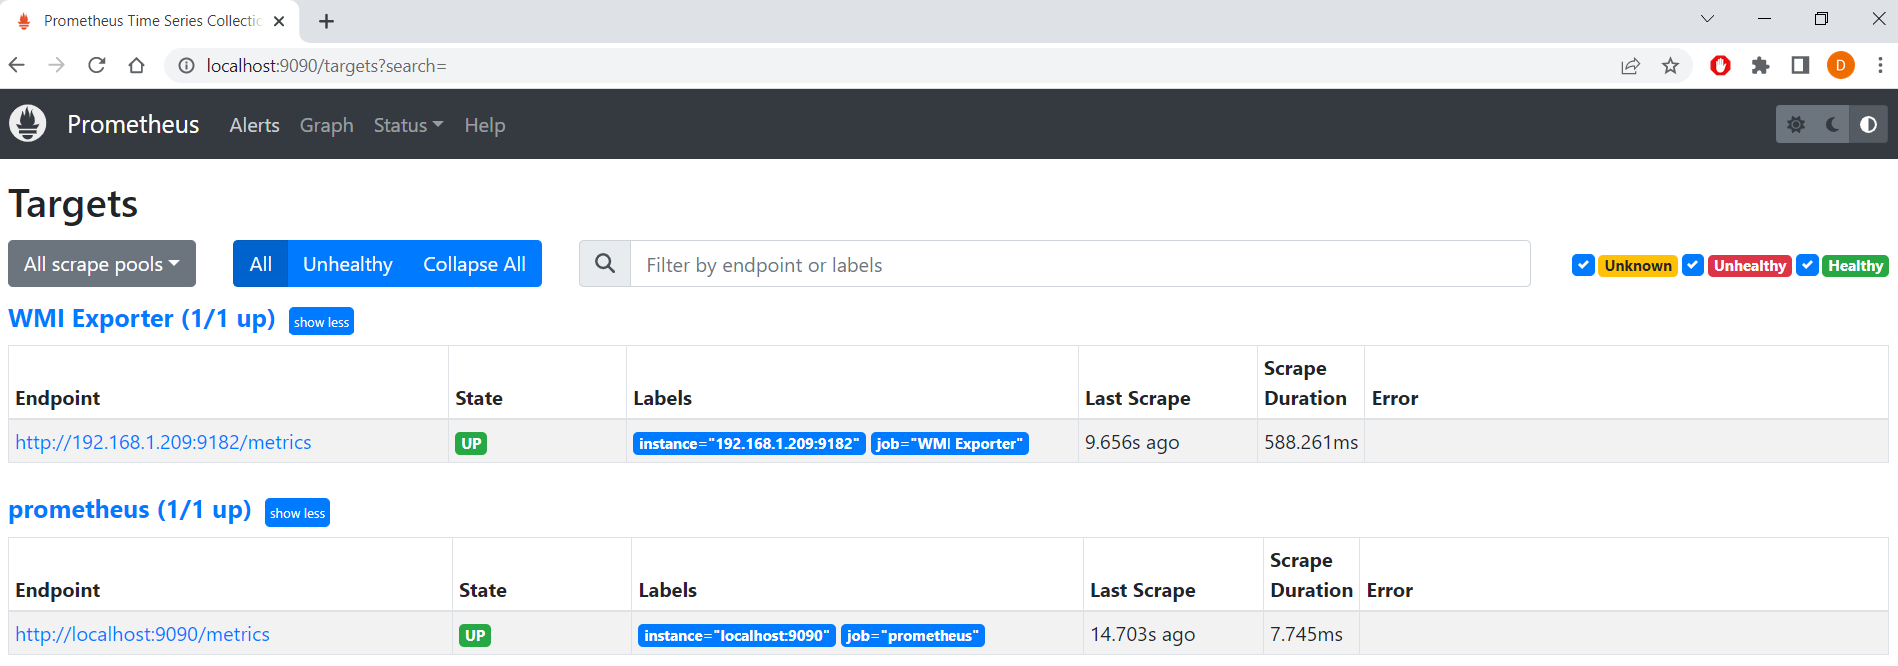

**3. Monitoring test.**

- in the Expression field, we can check lots of different metrics. For the example here, we will check the download speed of our computer with the following expression:

**rate(windows_net_bytes_received_total[1m])**

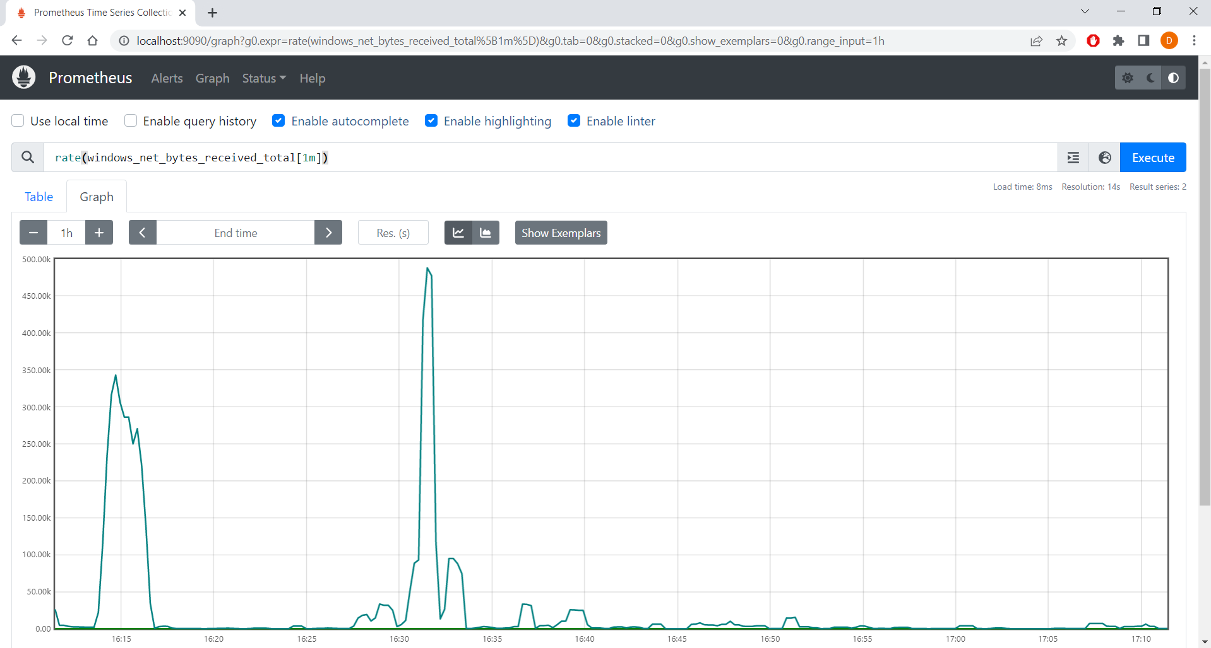

- full list of metrics of each Collector and what they do can be found in the github page of the Exporter - <https://github.com/prometheus-community/windows_exporter> when scrolling down and clicking on any of the Collectors.